Brunstane Primary School, Edinburgh
Three topics for 2021-2023: Litter (mandatory), Biodiversity, Food and the Environment
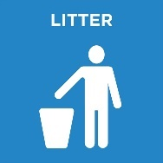
Date range of litter plan: April 2021 (when children returned to school following closure)-April 2023

Our overall aim of the plan: to have minimal litter in our grounds to make the playground a clean place for learning and play

Action | Who’s in charge? | When will it be done by? (If it is ongoing then when did it start?) | How can we measure it? | 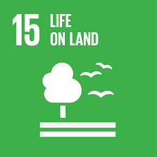  How does your action link to your chosen SDG? | Did it work?  Any ideas for  the future?
New bins  Bins in the back field | Eco Committee | Bins are expensive so this may take some time. It may take a campaign! | Compare the amount of litter in the bins and litter on the ground | We want to care for our land. When there is litter it affects the wildlife that use our land which impacts on the ecosystems.
Give stickers to P1 and P2s that use bins – which class uses bins the most? other ideas e.g. reward chart? | P2 reps – Zoe and Michael  PSAs | Ongoing, starting in June 2021 | Keep record of classes who have most stickers | ‘Life on land’ involves the protection of land and we are aiming to protect the land by reducing litter which contaminates the land.
Update litter policy | Paul and Summer (P6) | By September 2021 | Measure children’s understanding of why reducing litter matters for life on land (and water)
Refresh litter posters – new campaign – to hang on doors to remind everyone when they go outside | Eco reps | By September 2021  (posters will be designed and different ones can be used each month to keep the campaign fresh)
‘Please use bins’ chalk markings in P3-7 playground | Sydney & Lucas (P4) | Ongoing, starting in June 2021
Cartoon character poster on bin – to attract kids to the bins | Eco reps | By December 2021 | Feedback from children to see if it has made positive difference
Community Spring Clean – KSB  Include Litter pick lesson on the same day | Mrs Ritchie  Paul and Summer | Annual – May/June | Before and after pics  Feedback from those involved
Class litter picks | Different classes’ responsibilities throughout the year depending on in-class projects  Mrs Ritchie to replenish litter picker supply | Ongoing, starting in August 2021 | Weight/number of bags of litter collected
Litterpick with Playrangers | Mrs Ritchie & Megan from Play Ramgers | Termly dates – to be confirmed | Amount of litter collected, increase in number of children using bins
Focus on development of the school grounds and outdoor learning | School ground development team (Parent Council, staff and pupils) | May 2021 onwards
Continue making ‘Eco bricks’ so crisp bags and other snack litter can be put to good use | Miss Campbell and P5 (next year’s P6) | April 2021 onwards | Number of Eco bricks made
Continue to eat snacks inside post Covid restrictions | Eco Committee | Ongoing (from March 2021) | Feedback from Audrey (janitor)  Less litter on ground
Promote ‘no waste’ healthier snacks | Eco Committee | September 2021 | Number of people with ‘Snack with no packs’


Date range of biodiversity plan: May 2021-April 2023

Our overall aim of the plan: to increase the diversity of wildlife in our grounds

Action | Who’s in charge? | When will it be done by? (If it is ongoing then when did it start?) | How can we measure it? | How does your action link to your chosen SDG? | Did it work?  Any ideas for  the future?
Research and build habitats/shelters for insects, birds, butterflies, squirrels and hedgehogs | All classes have expressed an interest in building animal habitats so various classes likely to take this on – to be updated | Throughout the 2021/22 session | Through citizen science projects where wildlife visitors are monitored and measured before, during and after shelters are built  Webcams | ‘Life on land’ involves restoring and promoting sustainable use of terrestrial ecosystems. We want to protect diversity and natural habitats.
‘Wildlife’ of the month to raise awareness of the visitors to our playground and what they need to survive and thrive | Eco Committee | Throughout the 2021/22 session – and beyond? | Feedback from the school community on the wildlife in the school grounds
Add signage to bug hotels and other habitats to encourage everyone to look after them | Eco committee in cooperation with classes | Throughout 2021/22 session
Opportunities to visit the orchard & burn path to survey habitats e.g. ducks | Nursery and P1 | Throughout session 2021/22 | Pictures of habitats and wildlife and knowledge of children
Raise awareness of the importance of bees. Possibility a beehive? (next session) | P4/5  Ms Chelkowska | May-June 2021 | Feedback from members of the school community who have learned new information | Bees are essential for life on land.
Bird feeders and water bowls for birds  (and visiting cats!) | Eco reps | Autumn/Winter 2021 | Numbers/variety of bird species in playground | Birds play a vital role in the ecosystem and they are more likely to visit if we provide water.
Check the flowers in the Edible Garden are bee friendly and plant more | Eco Committee | April 2022 | Monitor bee numbers by carrying out a survey

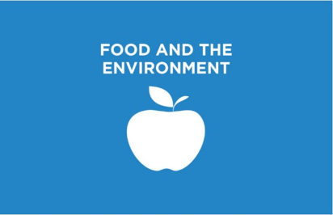
Date range of plan: May 2021-April 2023

Our overall aim of the plan: to grow some produce good enough to eat!

Action | Who’s in charge? | When will it be done by? (If it is ongoing then when did it start?) | How can we measure it? | 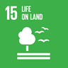  How does your action link to your chosen SDG? | Did it work?  Any ideas for  the future?
Opportunities to learn about/grow food every year | Staff – looking at our curriculum and providing opportunities for growing | Throughout session 2021-22 | Number of children involved in growing food – data of numbers before and after | A flourishing ‘life on land’ is the foundation for our life on this planet.
Tidy Edible Garden to encourage growth | Mrs Ritchie with staff volunteers | Termly – starting in June 2021 | Pictures and details of fruit yield
Improving opportunities to use Edible Garden – teaching young people how to tend to the plants/trees  After school club? | Mrs Ritchie  Other staff?  Parent Council?  Parents? | Dependent on grant funding applications | Number of participants, level of knowledge around how food grows and ability with practical skills
Hosting a ‘One Planet Picnic’ | Eco Committee  Nursery | Before the end of 2022 | Number of people who attend
Increase number of school outings with a ‘Food and the Environment’ theme | Staff team – identifying opportunities throughout the year linked to various projects | Before the end of 2022 | Number of children who have participated
Improve compost facilities | Eco Committee  Nursery | March 2022 | Amount of compostable waste added to compost bins

* Please note that in the August inservice days we are planning to redesign areas of our curriculum. In particular we are looking at recontextualising our ‘bundles’ to focus on Learning for Sustainability themes e.g. children’s rights, diversity, environmental issues. There will be further updates to the plan especially with regards to which class are leading different actions on the plan.

