 | Brunstane Primary School  106 Magdalene Drive  EDINBURGH  EH15 3BE  Chris McMillan, Head Teacher

Monday 21st October 2024
Dear Parents/Carers,

I hope you all had a good October break. We look forward to welcoming back all of our families tomorrow. It has been a very busy first term back at Brunstane with many of our classes settling in to their new accommodation in the playground. Work has now begun on site over the October break, so there are a number of important changes to let you know about, as well as a number of other pieces of news and important reminders.

Infrastructure Update
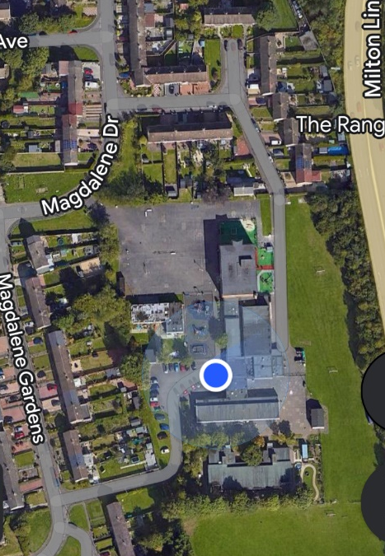
The contractors are now on site and have closed off the tower block section of the school and some areas of the playground. We are working very closely with the construction team and Council colleagues to ensure that all changes to the site are carefully risk assessed and allow our normal school routines to continue as much as possible.

Families will see an increase in works traffic as materials are delivered to site. These are being carefully managed to ensure that vehicles do not access the playground whilst children are outside learning. From this point until the end of the construction works, the road and pedestrian gates at the north east corner of the site will be closed to all other traffic (with the exception of pick ups and drop offs for our ESB classes).

We therefore request that all families use the gate at the north west of the site on Magdalene Drive or the gate by the carpark on Magdalene Gardens as the only entrances and exits to the school site, as these will be well away from any construction traffic.

When you are next on site, you will see that there are several areas of the grounds that are currently fenced off. We will be reminding pupils that this is for safety reasons and that pupils should not be playing near these areas. We are moving some of our play infrastructure and will be making use of the back field as a key play area to make up for the lost space.
We would be very grateful if you could reinforce these safety messages to your children, especially if they come to the school grounds to play after hours when there will not be staff on site.

There are no changes to where pupils are lining up or to pick up or drop off times.

We will inform families of any further changes to the site layout as soon as we have them.

Keeping information up to date
Throughout the year please keep us up to date with any changes to your contact details. We send a lot of information out via text message and need an up to date mobile phone number for this to work. We will send out a data collection sheet at the beginning of term, please look out for this, check the details and return the form to school.

KIC forms
One of the key documents we need from all families is a completed KIC form to allow your child to attend school trips and outdoor learning experience in the local area. Please ensure you have returned these to school – we cannot take children out of the building without one and they are very upset if they are not able to attend trips with their classmates. We cannot accept verbal permission for trips.

Attendance Campaign
We were delighted to significantly reduce the number of pupils with low attendance last year. Many families will have seen our attendance campaigns on the school website and on Twitter. We are determined to bring this down even further. We ask parents to help us with this campaign. Please avoid booking term-time holidays and please make sure your child comes to school on a Friday. We have made sure that Fridays are packed with fun learning experiences your child will not want to miss. If there are any issues that make it hard for your pupil to attend school, please call the school on 0131-669-4498 and one of our Pupil Support Officers will make a plan to help you. We can support with help with uniforms, winter clothing, food and washing facilities amongst other supports and want to help out however we can. The table below shows the impact that missing school can have.

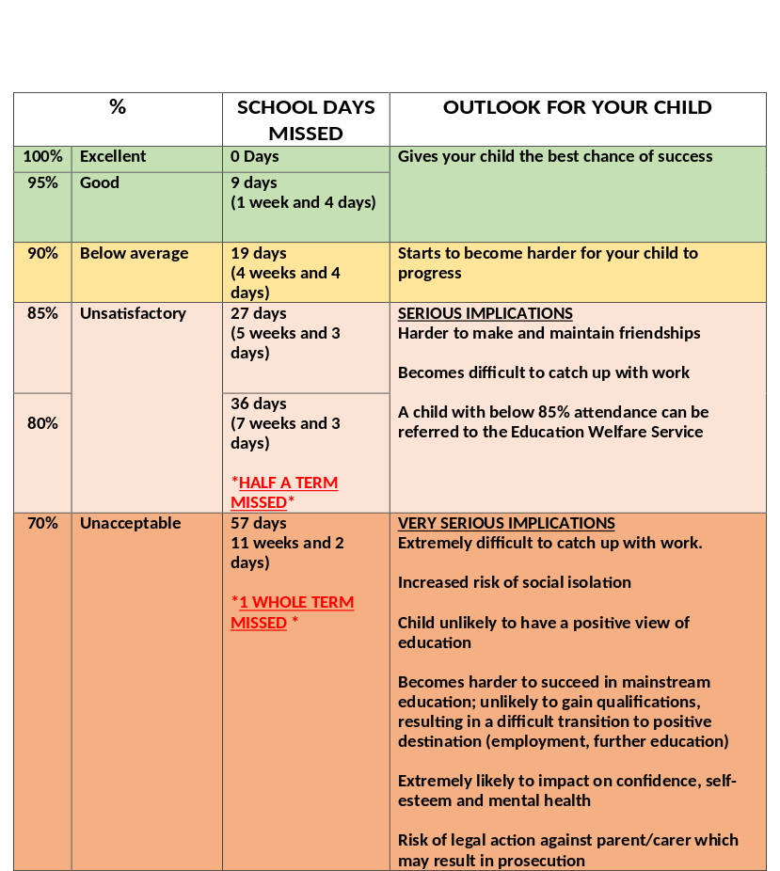

Parking
We continue to receive reports about cars parked in a dangerous manner at drop off times. We would like to politely request that parents do not park on pavements or block driveways. Please obey all road markings in order to ensure pupil safety.

We would also like to remind families that the school car park is for staff and blue badge holders only.

Dogs
Please remember that dogs are not allowed anywhere on the school campus.

Absence Calls
We would like to remind parents and carers that it is extremely important to phone the school to let us know if your child is going to be absent. If your child is unwell, please include what type of illness you think it may be when you leave a message.

Yours sincerely

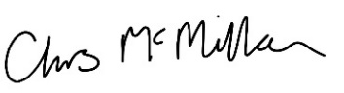

Chris McMillan
Head Teacher

Email admin@brunstane.edin.sch.uk | Tel 0131 669 4498
X @BrunstanePS | Web: www.brunstaneps.com

